1) Monitoring well in front of the Civil Engineering Building
Coordinates: 33°35'12.7"N 101°52'25.5"W

2) Pipes coming out of the Civil Engineering Building
Coordinates: 33°35'11.8"N 101°52'26.1"W
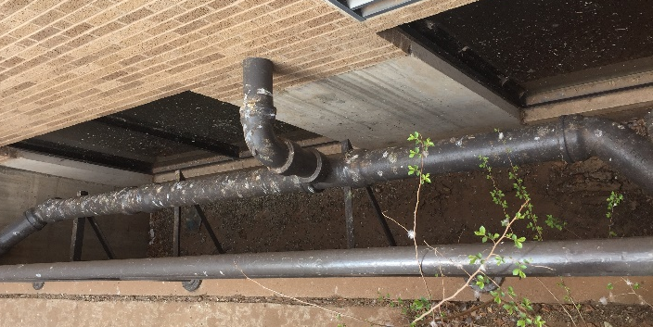
3) Manhole (sewer) at Lot R14 in front of the Civil Engineering Building
Coordinates: 33°35'12.6"N 101°52'24.2"W
4) Fountain at entrance
Coordinates: 33°35'04.1"N 101°52'17.8"W

5) Fountain at memorial circle
Coordinates: 33°35'04.1"N 101°52'28.3"W

6) Fountain in the Holden Hall
Coordinates: 33°35'07.6"N 101°52'25.9"W

7) Fountain-1 at the library
Coordinate: 33°34'53.6"N 101°52'37.6"W
8) Fountain-2 at the library
Coordinates: 33°34'52.5"N 101°52'37.6"W
9) Fountain in front of the English Department
Coordinates: 33°34'51.1"N 101°52'45.3"W

10) Pond at Urbanovsky Park, Flint Avenue
Coordinates: 33°34'51.5"N 101°52'58.3"W

11) Drain pipe coming out of Flint garage
Coordinates: 33°34'45.6"N 101°52'53.2"W

Credits: Photos are taken from Google Maps, TTU website and self-taken

