Cheol Hwan Im
Mira Prism Report
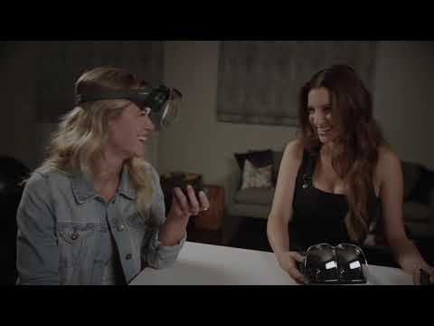
Overview - Mira Prism is a wireless AR headset that allows the user to interact with holographic images overlaid on the real world. It was started by three students from USC who got funding from various sources to create a AR glasses.
Used for - Used mostly for entertainment purposes such as watching TV, browsing the internet, playing games either single player or multiplayer. Other uses include educational purposes such as displaying models of molecules, bugs or animals to show students what the subject looks like in a 3D space.
The Basics – The kit comes with a magnetic lens, headset, launch pad, and remote. The Prism is wireless, so it does not require a wired connection to a computer to function. The lens attaches itself to the headset and the phone goes into the headset with the Mira prism app running. The remote is used for basic controls when interacting with the AR model. The Launch Pad is where the model appears on top of.
Good use of AR - The Prism Kit retails for 99 dollars making it affordable for general consumers. With it being available to a larger audience with a smaller price tag it will help AR become more popular. Using the phone as the main component it makes it more easily accessible for everyone. The Prism app allows spectators to see what the user is seeing by using their phones.
Strength - The Prism is affordable and mainly uses the phone for it to function. Unity based so the projects can be converted easily to run on the Prism Allows user to work collaboratively on Projects
Weakness - It requires the launch pad to show the figure in the Prism Not compatible as of now for Android phones and iPhone 8 and up.
Sickness - Rating is 1 since there isn’t a lot of movement involved when using the product.
Related Products-
Microsoft HoloLens $3000.00
Epson Moverio BT-300FPV Drone Edition $699
Garmin Varia Vision $370
These are some of the other AR sets but they cost more.

Potential - For entertainment purposes you could watch a sports game on your table. An Overlay over instruments to help teach people to play instruments. Maybe have models show up for textbooks without having to use the Launch Pad
Conclusion - Mira Prism AR headset is an affordable AR headset that allows people to enjoy AR conveniently at their home without having to pay high prices.
References
slides
https://docs.google.com/presentation/d/1YF9UhuGy3EFQ7b1rm2biz1XCd9J0eQahhphc7crmpqY/edit?usp=sharing
Prism AR
https://www.mirareality.com/

